

A MINI PROJECT REPORT

on

JOB APPLICATION PORTAL

Submitted by

ANAND - 1NH24CS592-T

Under the guidance of

Ms. M. THANGA SUBHA DEVI
Sr. Assistant Professor

In partial fulfillment for the award of the degree of

BACHELOR OF ENGINEERING
in
COMPUTER SCIENCE AND ENGINEERING
Academic Year: 2025-26 (ODD SEM)

CERTIFICATE

This is to certify that the mini project work titled “Job Application Portal” is a Bonafide work carried out by ANAND (1NH24CS592-T) in partial fulfillment of the degree of Bachelor of Engineering in Computer Science and Engineering of the New Horizon College of Engineering during the year 2025-2026.

Signature of Guide Signature of HOD

SEMESTER END EXAMINATION

Name of the Examiner Signature with date

1.

2.

ABSTRACT

The Job Application Portal is a web-based platform designed to streamline the job application process for both job seekers and employers. The portal provides a comprehensive interface that includes company information, job descriptions, vacancy listings, and an interactive application form.
The website features a modern, responsive design with smooth navigation between sections including About, Vacancies, Apply, and Job Description. Users can view available positions across different roles such as Frontend Developer, Backend Developer, UI/UX Designer, and Full-stack Developer along with their respective salary ranges and locations.
The application form captures essential candidate information including name, email, phone number, preferred position, resume upload, and a personal statement. Upon successful submission, users receive instant visual feedback through a modal confirmation dialog.
The portal is built using HTML, CSS, and JavaScript, incorporating modern design principles such as gradient backgrounds, smooth animations, and responsive layouts to ensure an optimal user experience across all devices

ACKNOWLEDGEMENT
The satisfaction and euphoria that accompany the successful completion of any task would be impossible without the mention of the people who made it possible, who’s constant guidance and encouragement crowned our efforts with success.

I have great pleasure in expressing gratitude to Dr. Mohan Manghnani, Chairman, New Horizon Educational Institutions, for providing necessary infrastructure and creating good environment.

I take this opportunity to express my profound gratitude to Dr. Manjunatha, Principal, New Horizon College of Engineering, for the constant support and encouragement.

I would like to thank Dr. Anandhi R J, Professor and Dean-Academics, NHCE, for her valuable guidance.

I would also like to thank Dr. B. Rajalakshmi, Professor and HOD, Department of Computer Science and Engineering, for the constant support.

I also express my gratitude to Ms. M. Thanga Subha Devi, Sr. Assistant Professor, Department of Computer Science and Engineering, my mini project reviewer, for constantly monitoring the development of the project and setting up precise deadlines. Her valuable suggestions were the motivating factors in completing the work.

ANAND

1NH24CS592-T

CONTENTS
ABSTRACT | I
ACKNOWLEDGEMENT | II
CONTENTS | III
LIST OF FIGURES | V
- INTRODUCTION | 1
1.1 PROBLEM DEFINITION | 1
- OBJECTIVES | 2
METHODOLOGIES TO BE FOLLOWED | 3
EXPECTED OUTCOMES | 4
- FUNDAMENTALS OF THE LANGUAGES USED | 5
2.1 HTML | 5
2.2 HTML TAGS | 6
2.3 CSS | 7
2.4 JAVASCRIPTS | 9
- REQUIREMENT SPECIFICATION | 10
3.1 HARDWARE REQUIREMENTS | 10
3.2 SOFTWARE REQUIREMENTS | 11
- DESIGN | 12
4.1 DESIGN GOALS | 12
- IMPLEMENTATION | 13
5.1 HEADER AND NAVIGATION | 13
5.2 SECTIONS LAYOUT | 14

5.3 | STYLING AND ANIMATIONS | 16
5.4 | APPLICATION FORM | 19
5.5 | FUNCTIONS | 20
5.6 | MODAL IMPLEMENTATION | 21
- RESULTS |  | 22
6.1 | HOME PAGE | 22
6.2 | VACANCIES TABLE | 23
6.3 | APPLICATION FORM | 24
6.4 | SUCCESS MODAL | 25
- CONCLUSION |  | 26
REFERENCES 27

LIST OF FIGURES

Figure No. | Description | Page No.
5.1.1 | Code snippet for Header Section | 13
5.1.2 | Code snippet for Navigation Bar | 13
5.2.1 | Code snippet for About Section | 14
5.2.2 | Code snippet for Job Description Section | 14
5.2.3 | Code snippet for Vacancies Table | 14
5.3.1 | Styling for Body and Header | 15
5.3.2 | Styling for Navigation | 16
5.3.3 | Styling for Application Form Box | 16
5.3.4 | Styling for Form Elements | 17
5.4.1 | Application Form HTML Structure | 19
5.5.1 | Submit Form Function | 20
5.5.2 | Close Modal Function | 21
5.6.1 | Modal HTML Structure | 21
5.6.2 | Modal Styling and Animation | 21
6.1.1 | Home Page Result | 23
6.2.1 | Vacancies Table Result | 24
6.3.1 | Application Form Result | 25
6.4.1 | Success Modal Result | 26

LIST OF TABLES

Table No. | Description | Page No.
2.1.1 | HTML Tags | 6
2.2.1 | CSS Properties | 7
5.2.1 | Job Positions and Details | 15

CHAPTER 1

INTRODUCTION

The Job Application Portal is a comprehensive web-based solution designed to modernize and streamline the recruitment process. In today's digital age, having an efficient and user-friendly platform for job applications is crucial for both employers and job seekers. This portal serves as a bridge between talented individuals seeking employment opportunities and companies looking to hire skilled professionals.
The portal focuses on providing a seamless experience through intuitive navigation, modern design aesthetics, and functional features that make the application process straightforward and efficient.

PROBLEM DEFINITION
The traditional job application process often involves multiple challenges that can hinder both employers and job seekers. Many companies still rely on outdated methods of collecting applications, leading to inefficiencies and poor user experiences.
Key problems addressed by the Job Application Portal include:
- Fragmented Information: Job seekers often struggle to find comprehensive information about companies, available positions, and application requirements in one place.
- Poor User Experience: Many existing job portals lack modern design principles, making navigation difficult and discouraging potential applicants.
- Lack of Instant Feedback: Traditional application methods fail to provide immediate confirmation to applicants, leaving them uncertain about their submission status.

- Non-Responsive Designs: Many job portals are not optimized for mobile devices, limiting accessibility for users on different platforms.
- Complex Application Processes: Overly complicated forms and unclear instructions can deter qualified candidates from completing their applications.

OBJECTIVES
The primary objectives of the Job Application Portal are:
- Centralized Information Hub: Provide a single platform where job seekers can access company information, job descriptions, vacancies, and application forms.
- Modern User Interface: Create an aesthetically pleasing and intuitive interface that enhances user engagement and satisfaction.
- Streamlined Application Process: Simplify the application process with a well-structured form that captures essential candidate information efficiently.
- Instant Feedback Mechanism: Implement visual confirmation through modal dialogs to acknowledge successful application submissions.
- Responsive Design: Ensure the portal is accessible and functional across all devices and screen sizes.
- Professional Presentation: Present company culture and values effectively to attract quality candidates.
- Data Validation: Implement form validation to ensure accurate and complete information collection.
- Smooth Navigation: Enable seamless scrolling and navigation between different sections of the portal.

METHODOLOGIES TO BE FOLLOWED

The following methodologies will guide the development and implementation of the Job Application Portal:

1.3.1 Design and Planning
- Wireframing: Create initial layouts and structure for the portal sections.
- Color Scheme Selection: Choose professional and appealing color combinations.
- Typography Planning: Select appropriate fonts for readability and aesthetics.

1.3.2 Implementation
- Semantic HTML: Use proper HTML5 elements for structure and accessibility.
- CSS Styling: Implement modern CSS features including flexbox, gradients, and animations.
- JavaScript Functionality: Add interactivity through form handling and modal operations.
- Responsive Design: Utilize media queries for cross-device compatibility.

1.3.3 Testing and Validation
- Cross-Browser Testing: Ensure compatibility across different web browsers.
- Form Validation Testing: Verify that all form validations work correctly.
- Responsive Testing: Test the portal on various screen sizes and devices.

  - EXPECTED OUTCOMES
The Job Application Portal is expected to deliver the following outcomes:
- Enhanced User Experience: A visually appealing and easy-to-navigate portal that encourages users to explore and apply.

- Efficient Information Delivery: Clear and organized presentation of company information, job descriptions, and vacancies.

- Simplified Application Process: A streamlined form that reduces friction in the application process.

- Professional Brand Image: A modern portal that reflects positively on the company's brand and culture.

- Increased Accessibility: A responsive design that allows users to access the portal from any device.

- Data Collection Efficiency: Structured collection of candidate information for easy processing.

CHAPTER 2

FUNDAMENTALS OF THE LANGUAGES USED

The Job Application Portal is built using the three fundamental languages of web development: HTML, CSS, and JavaScript. These languages work together to create structured, styled, and interactive web pages.

HTML (Hyper Text Markup Language)

HTML is the standard markup language for creating web pages. It structures the content of a webpage using elements enclosed in tags.
HTML (Hyper Text Markup Language) was created by Tim Berners-Lee in 1989 as part of the World Wide Web project at CERN, aimed at enabling scientists to share documents through hyperlinks. The first version of HTML was introduced in 1991, consisting of 18 basic tags like <h1> and <p>. In 1995, HTML 2.0 became the first standardized version, introducing new features like forms and tables. Subsequent updates, such as HTML 3.2 in 1997, added support for CSS, while HTML 4.0 in 1999 integrated multimedia elements and scripting capabilities. HTML5, introduced in 2014, revolutionized the web by adding semantic elements, multimedia capabilities, and cross-platform support.
Key Features:
- Structure: Defines elements like headings, paragraphs, lists, and images.
- Links: Connects to other documents using hyperlinks.
- Forms: Captures user input through various input elements.

HTML TAGS

Common HTML Tags and Their Descriptions:
Tag | Description
<html> | Root element of an HTML document.
<head> | Contains metadata, title, and linked resources.
<title> | Defines the title displayed in the browser tab.
<body> | Contains the main content of the document.
<header> | Defines a header section for the document.
<nav> | Defines navigation links.
<main> | Specifies the main content of a document.
<section> | Defines a section in a document.
<h1> to <h6> | Defines headings, <h1> is the largest.
<p> | Defines a paragraph.
<a> | Creates hyperlinks using the href attribute.
<table> | Creates a table structure.
<tr> | Table row.
<td> | Table cell.
<th> | Table header.
<form> | Defines a form for user input.
<input> | Defines an input field (e.g., text, email, file).
<select> | Creates a dropdown list.
<textarea> | Defines a multi-line text input.
<button> | Defines a clickable button.
<footer> | Defines a footer for a document.
Table No. 2.1.1 HTML Tags

CSS (Cascading Style Sheet)

CSS (Cascading Style Sheets) was introduced in 1996 by the World Wide Web Consortium (W3C) as a solution to separate the content of web pages from their presentation. The concept was first proposed by Håkon Wium Lie in 1994, aiming to provide web developers with a way to control the appearance of web pages without altering their HTML structure.
CSS3, introduced as a modular update, brought transformative features like animations, transitions, and responsive design through media queries. Today, CSS remains a fundamental technology in web development, empowering developers to create visually engaging and responsive websites.
Key Features:
- Selectors: Targets HTML elements (e.g., p, #id, .class).
- Box Model: Defines padding, border, and margin for layout.
- Flexibility: Enables responsive design and animations.
Common CSS Properties and Their Descriptions:
Property | Description
color | Sets the text color.
font-family | Specifies the font.
font-size | Sets the text size.
background | Sets background color or image.
background-image | Sets a background image.
margin | Defines space outside the element's border.
padding | Defines space inside the element's border.
border | Defines the border around an element.
border-radius | Creates rounded corners.
display | Specifies layout behavior (e.g., flex, block).
position | Specifies positioning method.
transition | Defines smooth property changes.
animation | Creates keyframe animations.
box-shadow | Adds shadow effects to elements.
linear-gradient | Creates gradient backgrounds.
Table No. 2.2.1 CSS Properties

JAVASCRIPT
JavaScript is a high-level, lightweight, and versatile programming language primarily used to create interactive and dynamic web applications. It enables developers to add features such as animations, form validations, and real-time content updates.
Initially developed by Brendan Eich at Netscape in 1995, it was originally called Mocha, later renamed LiveScript, and eventually JavaScript to align with the popularity of Java at the time. JavaScript gained widespread adoption with the introduction of ECMAScript standards in 1997, which ensured consistency across implementations.
Key Features and Applications:
- DOM Manipulation: Selecting and modifying elements dynamically using methods like getElementById().
- Event Handling: Responding to user actions like clicks and form submissions.
- Form Validation: Ensuring proper user input before submission.
- Local Storage: Storing data in the browser for persistence.
Modal Control: Showing and hiding overlay dialogs programmaticall
CHAPTER 3

REQUIREMENT SPECIFICATION

HARDWARE REQUIREMENTS:

- Processor:
  - Minimum: Dual-core processor (e.g., Intel Core i3 or equivalent).
  - Recommended: Quad-core processor or higher for multitasking.
- RAM:
  - Minimum: 2 GB (sufficient for lightweight operations).
  - Recommended: 4 GB or higher.
- Storage:
  - A minimum of 100 MB of free space (to store the HTML file, assets, and browser cache).
- Display:
  - Screen resolution of at least 1024x768 to accommodate the portal UI.
  - A modern display supporting standard web colors.
- Input Devices:
  - Keyboard and mouse (or touch input for tablets and mobile devices).
- Internet Connection:

Required for loading external background images and fonts

SOFTWARE REQUIREMENTS:

- Operating System:
  - Windows (7 or higher), macOS (10.12 or higher), or a modern Linux distribution.
  - For mobile: Android 5.0+ or iOS 10+.
- Web Browser:
  - Modern web browsers like:
    - Google Chrome (latest version preferred).
    - Mozilla Firefox (latest version preferred).
    - Microsoft Edge (latest version).
    - Safari (for macOS/iOS).
  - Ensure the browser supports ES6 JavaScript and CSS3 features.
- Text Editor/IDE (for development or modification):
  - Visual Studio Code, Sublime Text, Atom, or any modern text editor.
- Web Server (Optional):
  - For local hosting (if not opening directly in a browser):
    - Use a lightweight server like Python's built-in HTTP server or tools like XAMPP.
- Dependencies:
  - No external JavaScript libraries are required.
  - Ensure JavaScript is enabled in the browser.

CHAPTER 4
DESIGN

4.1 DESIGN GOALS
- Professional Appearance: Create a professional and corporate-looking interface that instills trust and credibility in job seekers while representing the company's brand effectively.
- User-Centric Navigation: Implement smooth scrolling navigation with a sticky navbar that allows users to easily access different sections of the portal without losing their place.
- Visual Hierarchy: Use typography, spacing, and color contrast to establish clear visual hierarchy, guiding users' attention to important information and calls-to-action.
- Modern Aesthetics: Incorporate contemporary design elements such as gradient backgrounds, rounded corners, subtle shadows, and smooth transitions to create a visually appealing experience.
- Responsive Layout: Design the portal to adapt seamlessly to different screen sizes, ensuring mobile users have the same quality experience as desktop users.
- Clear Information Architecture: Organize content into logical sections (About, Job Descriptions, Vacancies, Application Form) that follow a natural flow for job seekers.
- Interactive Feedback: Provide immediate visual feedback for user interactions through hover effects, focus states, and confirmation modals to enhance user engagement.
- Accessibility Considerations: Ensure sufficient color contrast, readable font sizes, and proper labeling of form elements to make the portal accessible to all users.
- Form Usability: Design the application form with clear labels, appropriate input types, and validation to minimize user errors and improve completion rates.
- Brand Consistency: Maintain consistent use of colors, fonts, and styling throughout the portal to reinforce brand identity and create a cohesive user experience.

CHAPTER 5

IMPLEMENTATION

5.1 HEADER AND NAVIGATION
The header section displays a hero image with an overlay and the main title of the portal. The navigation bar is sticky and provides links to all major sections.
<header>
<h1 class="title">Find Your Career. You Deserve it.</h1>
</header>
Fig. No. 5.1.1 Code snippet for Header Section

<nav>
<ul>
<li><a href="#about">About</a></li>
<li><a href="#vacancies">Vacancies</a></li>
<li><a href="#form">Apply</a></li>
<li><a href="#job-description">Description</a></li>
</ul>
</nav>

Fig. No. 5.1.2 Code snippet for Navigation Bar

5.2 SECTIONS LAYOUT
<section id="about">
<h2>About</h2>
<p>Our company is built on innovation, integrity, and excellence...</p>
</section>
Fig. No. 5.2.1 Code snippet for About Section

<section id="job-description">
<h2>Job Description</h2>
<ul>
<li><strong>Frontend Developer</strong> — HTML, CSS, JS, React/Vue</li>
<li><strong>Backend Developer</strong> — Node.js, Python, SQL</li>
<li><strong>UI/UX Designer</strong> — Figma, Adobe XD</li>
<li><strong>Full-stack Developer</strong> — Front + Backend</li>
</ul>
</section>

Fig. No. 5.2.2 Code snippet for Job Description Section

<section id="vacancies">
<h2>Vacancies</h2>
<table>
<tr>
<th>Position</th>
<th>Openings</th>

<th>Location</th>
<th>Salary</th>
</tr>
<tr>
<td>Frontend Dev</td>
<td>34</td>
<td>Mumbai/Bengaluru</td>
<td>12–20 LPA</td>
</tr>
<!-- Additional rows -->
</table>
</section>
Fig. No. 5.2.3 Code snippet for Vacancies Table
Table No. 5.2.1 Job Positions and Details
Position | Openings | Location | Salary
Frontend Dev | 34 | Mumbai/Bengaluru | 12–20 LPA
Backend Dev | 26 | Remote | 12–24 LPA
UI/UX Designer | 18 | Mumbai/Hyderabad | 15–30 LPA
Full-stack Dev | 10 | BLR/HYD | 18–26 LPA

5.3 STYLING AND ANIMATIONS
body {
background: #f3f7ff;
color: #111;
}

header {
background-image: url("bg2.jpg.jpg");
background-size: cover;
background-position: center;
height: 330px;
display: flex;
align-items: center;
justify-content: center;
position: relative;
}

header::after {
content: "";
position: absolute;
inset: 0;
background: rgba(0, 0, 0, 0.45);
}
Fig. No. 5.3.1 Styling for Body and Header

nav {
background: #0e1a2b;
padding: 16px 0;
position: sticky;
top: 0;

z-index: 50;
}

nav ul li a:hover {
background: linear-gradient(90deg, #7ad0ff, #ff7a7a);
color: #001629;
}
Fig. No. 5.3.2 Styling for Navigation

#apply-box {
max-width: 650px;
margin: auto;
background: #0f1724;
padding: 35px;
color: #fff;
border-radius: 14px;
box-shadow: 0 8px 25px rgba(0, 0, 0, 0.45);
animation: fadein 0.7s ease;
}

@keyframes fadein {
from {
opacity: 0;
transform: translateY(35px);
}
to {
opacity: 1;
transform: translateY(0);
}
}
Fig. No. 5.3.3 Styling for Application Form Box
input, select, textarea {

width: 100%;
padding: 12px;

border-radius: 8px;
border: 1px solid rgba(255, 255, 255, 0.18);
background: #1c2537;
color: #fff;
outline: none;
font-size: 1rem;
}

input:focus, textarea:focus, select:focus {
border-color: #7ad0ff;
box-shadow: 0 0 0 3px rgba(122, 208, 255, 0.25);
}
Fig. No. 5.3.4 Styling for Form Elements

5.4 APPLICATION FORM
The application form collects essential candidate information with proper validation.
<form id="applyForm">
<div id="apply-box">
<label>Full Name *</label>
<input id="name" type="text" required>

<label>Email *</label>
<input id="email" type="email" required>

<label>Phone *</label>
<input id="phone" type="tel" required>

<label>Position *</label>
<select id="position" required>
<option value="">-- Select --</option>
<option>Frontend Developer</option>
<option>Backend Developer</option>
<option>UI/UX Designer</option>
<option>Full-stack Developer</option>
</select>

<label>Upload Resume</label>
<input id="resume" type="file" accept=".pdf,.doc,.docx">

<label>Why should we hire you?</label>
<textarea id="message" rows="5"></textarea>

<button type="button" class="btn-submit" onclick="submitForm()">

Submit Application
</button>
<button type="reset" class="btn-reset">Reset Application</button>
</div>
</form>
Fig. No. 5.4.1 Application Form HTML Structure

5.5 FUNCTIONS
function submitForm() {
const name = document.getElementById("name").value.trim();
const email = document.getElementById("email").value.trim();
const phone = document.getElementById("phone").value.trim();
const position = document.getElementById("position").value.trim();
const message = document.getElementById("message").value.trim();

if (!name || !email || !phone || !position) {
alert("Please fill all required fields.");
return;
}

localStorage.setItem("jobApplication", JSON.stringify({
name, email, phone, position, message
}));

document.getElementById("successModal").style.display = "block";
}
Fig. No. 5.5.1 Submit Form Function
function closeModal() {
document.getElementById("successModal").style.display = "none";
}
Fig. No. 5.5.2 Close Modal Function

5.6 MODAL IMPLEMENTATION
The success modal provides visual confirmation when an application is submitted successfully.

<div id="successModal">
<div class="modal-box">
<h3>✅ Application Submitted!</h3>
<p>Thank you for applying. We'll contact you soon.</p>
<button onclick="closeModal()">Close</button>
</div>
</div>
Fig. No. 5.6.1 Modal HTML Structure

#successModal {
display: none;
position: fixed;
inset: 0;
background: rgba(0, 0, 0, 0.6);

z-index: 9999;
padding-top: 150px;
}

.modal-box {
background: #ffffff;
padding: 30px;
max-width: 380px;
margin: auto;
border-radius: 12px;
text-align: center;
animation: pop .3s ease;
}

@keyframes pop {
from {
transform: scale(0.8);
opacity: 0;
}
to {
transform: scale(1);
opacity: 1;
}
}

Fig. No. 5.6.2 Modal Styling and Animation

CHAPTER 6

RESULTS

6.1 HOME PAGE
The home page displays a hero section with a background image, overlay, and the main title "Find Your Career. You Deserve it." The sticky navigation bar provides easy access to all sections of the portal. The About section presents comprehensive company information in a clean, readable format.
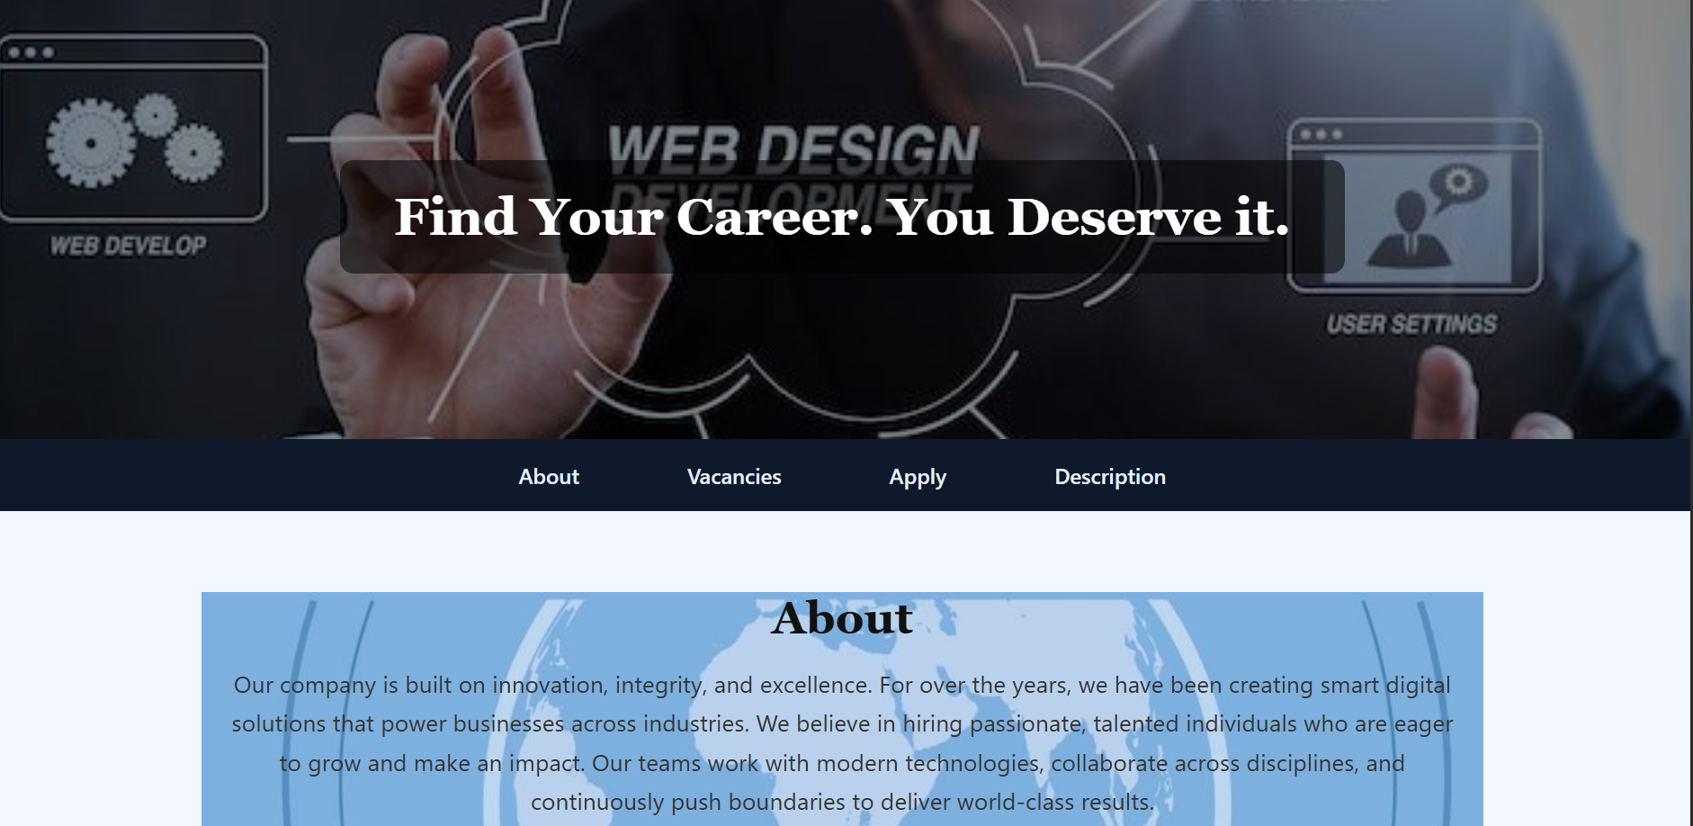

Fig. No. 6.1.1 Home Page Result

RESULTS

6.2 VACANCIES TABLE
The vacancies section presents available positions in a well-organized table format with alternating row colors for better readability. Information includes position titles, number of openings, locations, and salary ranges.
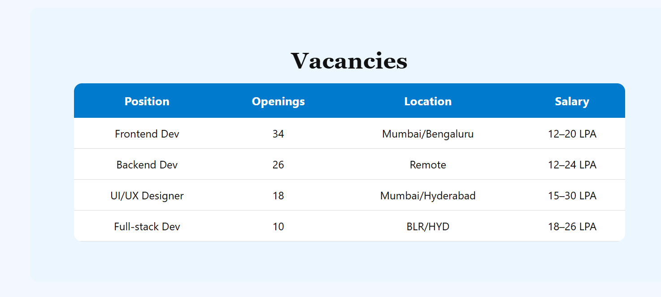

Fig. No. 6.2.1 Vacancies Table Result

6.3 APPLICATION FORM
The application form features a dark-themed design with proper spacing, clear labels, and various input types. The form includes text inputs, email field, phone field, dropdown selection, file upload, and text area.

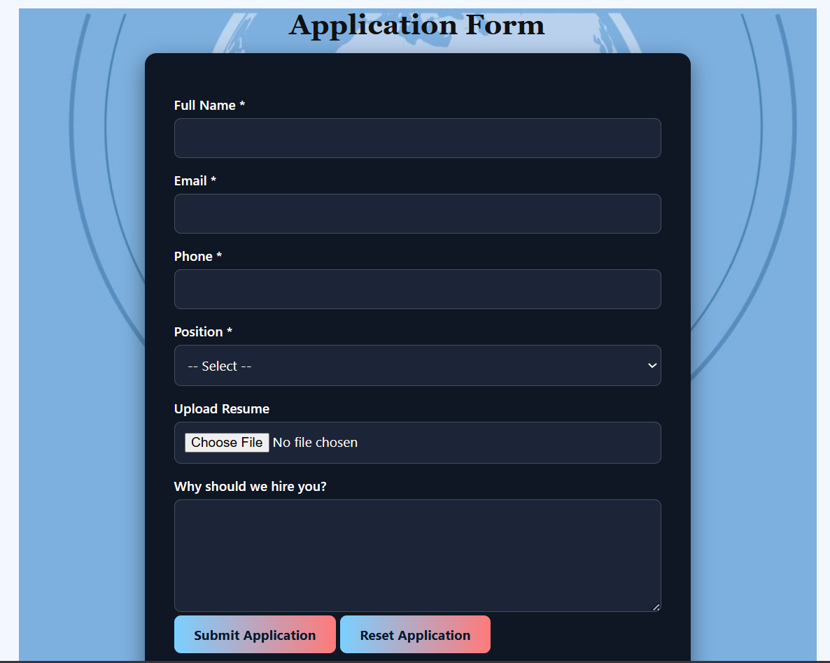

Fig. No. 6.3.1 Application Form Result

6.4 SUCCESS MODAL
Upon successful form submission, a modal dialog appears with a confirmation message, animated with a pop effect for visual appeal.

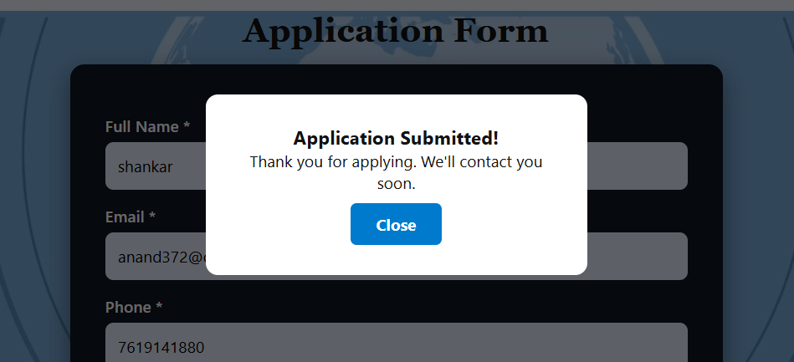

Fig. No. 6.4.1 Success Modal Result

CHAPTER 7

CONCLUSION

The Job Application Portal successfully combines modern web design principles with functional features to create an efficient and user-friendly platform for job applications. The project demonstrates effective use of HTML5 semantic elements for structure, CSS3 for styling and animations, and JavaScript for interactivity.
Key achievements of the project include:
- Professional Design: The portal presents a polished, corporate appearance that effectively represents a company's brand.
- Intuitive Navigation: The sticky navigation bar with smooth scrolling provides seamless access to all sections.
- Responsive Layout: The portal adapts well to different screen sizes, ensuring accessibility across devices.
- Interactive Elements: Hover effects, focus states, and animations enhance user engagement.
- Form Functionality: The application form captures essential candidate information with proper validation.
- Visual Feedback: The success modal provides immediate confirmation of form submission.
The project serves as a practical demonstration of fundamental web development concepts and can be extended with additional features such as backend integration, database connectivity, and advanced form validation in future iterations.

REFERENCES
- https://www.w3schools.com/html/
- https://www.w3schools.com/css/
- https://www.w3schools.com/js/
- https://developer.mozilla.org/en-US/docs/Web/HTML
- https://developer.mozilla.org/en-US/docs/Web/CSS
- https://developer.mozilla.org/en-US/docs/Web/JavaScript
- https://css-tricks.com/
- https://fonts.google.com/

